Longitudinal wave

This picture shows particles of air in a sound wave.
A vibrating object is making the air particles move.

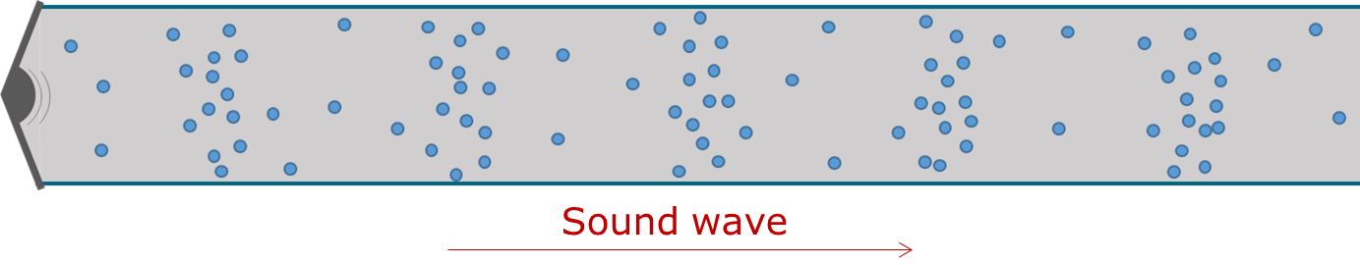
This picture shows particles of air when there is no sound wave.
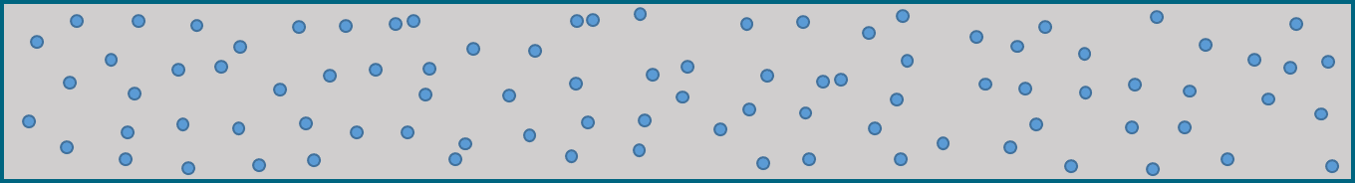

These statements are about the moving air particles in a sound wave.
For each statement, tick (✓) one column to show what you think.
 |  | I am sure this is right | I think this is right | I think this is wrong | I am sure this is wrong
A | Air particles can be pushed forward by other air particles that hit them.
B | Air particles vibrate and slowly move forward.
C | Air particles can bounce backward off the air particles they bump into.
D | Air particles move backwards and forwards over and over again.

Physics > Big idea PSL: Sound, light and waves > Topic PSL4: Waves > Key concept PSL4.2: A wave model of sound
Diagnostic question
Longitudinal wave

Overview
Learning focus: | As a sound wave (longitudinal wave) travels it transfers energy, as particles of the medium through which it travels are successively made to vibrate forwards and backwards along the direction in which the wave travels.
Observable learning outcome: | Explain how movement of each ‘particle’ of a longitudinal wave causes a perturbation to move forward.
Question type: | Confidence grid
Key words: | Sound wave, vibrate, vibration, longitudinal wave

What does the research say?
Finding out exactly what students are thinking about sound can be difficult, as they often label ideas of ‘sound particles’ with scientific terms: sound waves, disturbances, or vibrations. Superficially it can appear that students have a scientific understanding when they do not (Fazio et al., 2008).
The motion of waves is hard for students to understand because waves form from large numbers of small scale events, such as the backwards and forwards movement of air particles in a sound wave. These small scale events are quite different to the form and motion of the wave (Caleon and Subramaniam, 2010). This can be seen clearly when spectators at a sports event stand up and sit down in sequence to produce a Mexican wave, which moves around the stadium. A model longitudinal wave can be set up similarly, with students who are standing in a line stepping forwards and backwards in sequence. This process transfers energy through a medium, but without the transfer of any bulk substance.
Ways to use this question
Students should complete the confidence grid individually. This could be a pencil and paper exercise, or you could use an electronic ‘voting system’ or mini white boards and the PowerPoint presentation.
If there is a range of answers, you may choose to respond through structured class discussion. Ask one student to explain why they gave the answer they did; ask another student to explain why they agree with them; ask another to explain why they disagree, and so on. This sort of discussion gives students the opportunity to explore their thinking and for you to really understand their learning needs.
Differentiation
You may choose to read the questions to the class, so that everyone can focus on the science. In some situations it may be more appropriate for a teaching assistant to read for one or two students.

Expected answers
A, C and D are all correct statements; statement B is wrong.
How to respond - what next?
This question focuses on how the particles of air move within a sound wave, before any labels showing compressions or rarefactions are added to the wave, before it is labelled longitudinal and before the motion of the air particles in it are represented in a wave-diagram that looks just like a transverse wave. An idea of how air particles are moving in the wave is needed in order to form a scientific understanding of all of these things.
In the diagram of a sound wave shown in this question, a true representation would need to have an unimaginable number of particles – all too small to see. Instead, just a few particles have been shown, so that what is happening can be visualised more clearly.
What happens is that air particles, pushed forward by the loudspeaker cone, hit other air particles and bounce back off them. The particles they hit are pushed forwards in turn and the movement is passed on through the air. This results in individual air particles moving repeatedly forwards and backwards as the sound wave moves forward. Compressions are formed each time the loudspeaker cone moves forward, and these move forward with the sound wave.
When teaching how sound waves move through the air, we use the simplified model described above. This however, does not take account of the motion of air particles described by the kinetic theory. Instead we describe just the movement between gas particles that results in the forward motion of a wave. This bridging model builds towards a more complete understanding, but it does not answer every question a student might ask. For example, it does not explain why loud sounds travel at the same speed as a quiet sounds; or why high pitch sounds travel at the same speed as ones with a low pitch. The explanation given in the guidance notes for the BEST ‘Key concept’: A wave model of sound, goes beyond what your students need to understand at this stage, but it may be helpful to you in answering these challenging questions.
It is common for students to think that air particles move forwards in a sound wave. Statement B is a subtle version of this idea, which allows students to reveal this misunderstanding whilst also allowing them to repeat the scientific understanding that particles are moving forwards and backwards.
If students have misunderstandings about how movement of each ‘particle’ of a longitudinal wave causes a perturbation to move forward, it can help to model what is happening. This can be done with a line of students who are standing-to-shoulder. A gentle push on the shoulders of the one at the end can be transmitted along the line. The movement moves along the line, but the students do not. If the students did move along the line, then there would be nothing left for the speaker to push and it would no longer make sound waves!
The following BEST ‘response activity’ could also be used to model particle movement in follow-up to this diagnostic question:
- Response activity: Model sound wave
Acknowledgments
Developed by Peter Fairhurst (UYSEG).
Images: Peter Fairhurst (UYSEG).

References
Caleon, I. and Subramaniam, R. (2010). Development and Application of a Three-Tier Diagnostic Test to Assess Secondary Students' Understanding of Waves. International Journal of Science Education, 32:7, 939-961.
Fazio, C., et al. (2008). Modelling Mechanical Wave Propogation: Guidelines and experimentation of a teaching-learning sequence. International Journal of Science Education, 30:11, 1491-1530.

